**Clash Royale**

[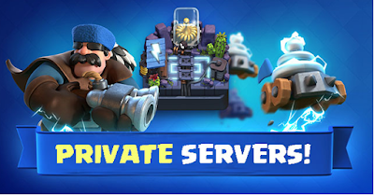](https://3.bp.blogspot.com/-2bR0Mpz1jr0/W84QaIKPqbI/AAAAAAAAAZg/TCwd5xoIzSID2TlMo3HvONQes0hfMyxAwCEwYBhgL/s1600/Clash-Royale-Modded-Server.png)

The most exciting game I have ever played and still playing. Since the release of the game, it was one of the top grossing game. Developers of the game were always busy with bringing some good updates for the players.

There are so many features or playing mode in the game. Like **1v1, 2v2, challenge mode or war**. War update was the best update of the [Clash Royale](https://clashroyale.com/). But it takes too much time for maxing up your account without money. It also takes so much money on maxing your account.

**My point of view:**

In my opinion, I won't spend money in this game. If you agree with me then you will think something else on your mind. You will search mod version or link of the private server.  If you are looking for something like that then you are in the right place. I will tell you about [Clash Royale](https://clashroyale.com/) private server and everything thorough about how to install it on Android or iOS in this article.

**What is Clash Royale private server?**

[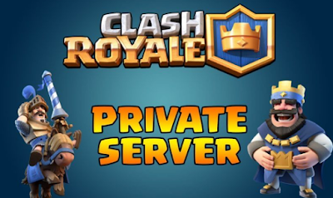](https://4.bp.blogspot.com/-SnF5DjQxIxY/W84QzaPBh6I/AAAAAAAAAZw/rvnbRHyOiis1MkPCxqFdCnVw1tb-6Z-7ACEwYBhgL/s1600/jsof.png)

For **unlimited resources** like **gold, elixir, gems** etc you have to play [Clash royale](https://clashroyale.com/) in private server. Private servers give you unlimited resources of every element of the game. If you are tired of losing with your opponent for having a low level of cards then the private server is the best thing for you. It gives you everything unlimited. For that, you don't have to worry about gems or golds. As I said everything is unlimited in Clash Royale private server. For that, you will have a whole new experience of the game.

**How does Clash Royale private server work?**

It's not that simple. Cracking the official game "[Clash Royale](https://clashroyale.com/)" is so much hard. If you try to crack then your id could be banned from the game. Because of rules and restrictions of [Supercell](https://supercell.com/en/) is so much hard. On that point, private servers rise. Private servers are a whole different thing from the game. It has no connection with the main game. But it's similar. Private server will not affect your main gaming id. In the private server, you will match up with another player who is playing on that server. You won't face any opposition from the real game. So you have to feel relaxed about private servers.

[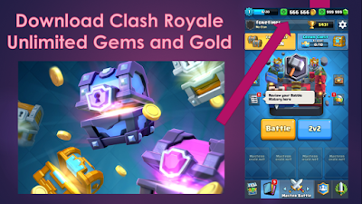](https://4.bp.blogspot.com/-zI-L90d48hs/W84QqCobyTI/AAAAAAAAAZk/v94bsKlGRGUJHLT00_vtvTi-DoNyVE3ugCLcBGAs/s1600/Royale.png)

**Features of Clash Royale private servers:**

* Unlimited golds.
* Unlimited Gems.
* New cards.
* New chests.
* Possible new cards which can be released in the main game.
* Playing with the opponent who is also playing in the same server.
* 2v2 battles.
* 1v1 battles.
* In game commands.
* Touchdown tournaments and other modes.
* Unlimited elixir.
* Playing with Custom made cards in the server.
* All cards are unlocked from the beginning.

**List of Clash Royale private servers 2018:**

* Rocket land
* Nulls Royale
* Clash of Hack
* Legendary Royale
* Xroyale
* Clash of duty
* FHX for Clash Royale
* ATfamily server
* Master Royale
* Clash of Yanis
* COG royale private servers
* Goblinland

**Pros and cons of the private servers:**

[](https://2.bp.blogspot.com/-ikr0d6xpJ_g/W84REuN37nI/AAAAAAAAAZ0/bV-_eHXMc2shkXMqaEL87nB15uTJbUsjQCLcBGAs/s1600/Pros-And-Cons-blog.jpg)

**Pros:**

As I said spending too much money on the game will not be the wisest choice. I would never do this because of the private servers. They are here just for you. To give you everything free. Every resource you want in the game can be acquired in the private server. You can also find some upcoming cards which supercell not even released. The main advantage of playing in private server is it has no connection with the official Clash Royale game. That's why you don't have to worry about your main gaming id. Also, the data of your main gaming it won't be lost by installing private server. You can also play with servers custom made cards. These will give you experiencing a great gameplay of Clash Royale.

**Cons:**

There aren't that many cons of private servers. Either you will face any trouble it not it fully depends on, in which server you are playing in. So you have to be cautious about downloading the proper apk of the server. You also have to be so much careful about your main game information. If any server wants your main gaming id's information, then don't give anything. They can be a scammer. They will hack your main gaming id. So be careful about it.

**Requirements for playing in private server:**

[](https://4.bp.blogspot.com/-6QlngGzGQJ0/W84RffMGm9I/AAAAAAAAAZ8/sefZun2OGg8_Q8lYnHd79Ql8CDqvKjGYgCLcBGAs/s1600/FCC-Closed-Captioning-Requirements-2.png)

1. Android version of your phone has to Android 4.4 or above.
2. Ram of your device has to 512MB or above.
3. Free extra spaces are also needed.

**How to install private server:**

[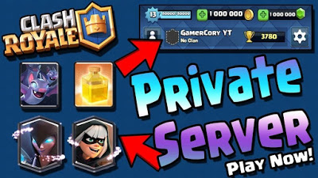](https://4.bp.blogspot.com/-vpf0IQcPMoE/W84RlA-kZYI/AAAAAAAAAaA/hv9T1l1CTbgYdAnNtB6pNYGg_FrkFOQbQCLcBGAs/s1600/Download-Latest-Clash-Royale-Private-Server-Apk4-1024x576.jpg)

For playing in the private server there is a process of installing it on your device. It's not that hard. If you do everything as my instruction then it will take only 3 to 5 minutes. Let's hear the **installation process:**

* First of all, you have to decide on which server you want to play. You have to download the apk file from that server's website.
* The file can be zipped. For this, you have to unzip the file.
* Permission for some unknown sources can be required. But you don't have to worry. Those are safe. You just have to permit these and gave access for playing the game.
* The private server is user-friendly that's why you just have to install the apk after above steps.

**The whole process can be done in a few minutes if you do everything as I told you.**

**Tips for giving the best competition:**

I am playing Clash Royale since its released date. Day by day its craze is increasing. It's so much competitive game for its versatile cards and decks. That's why you have to give the best competition to your opponent for winning the match. Private servers game plays and real game plays are the same. That's why I am going to share some pro tips for keeping up your winning percentage:

* **Building good decks:**

For giving the best competition to your opponent you have to build the best deck. Building a good deck it's a whole new point and discussion. You can take a look at an article about [How to build a good deck in clash royale](https://a1lifebeststyle.blogspot.com/2018/10/how-to-build-good-deck-in-cr-for.html)

* **Counting elixir:**

Counting your opponent's elixir is one of the best strategies in the game. In private server and also in the main game elixir count is so much important. By counting your opponent's elixir you will have the idea of how many elixirs your opponent has. Then you can think of attacking or defending.

* **Counting cards:**

You and your opponent can play with 8 cards in a deck. It means your opponent will spawn total 8 cards in one match one by one. If you count cards of the opponent then you will have the idea of which card you should play next or which card you shouldn't.

[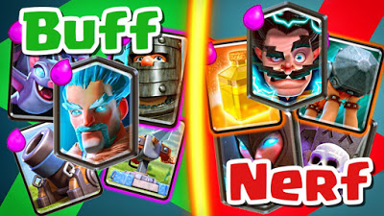](https://2.bp.blogspot.com/-EbPv42cNUKc/W84Rt48BsaI/AAAAAAAAAaE/EA7UC0jX5sk6uv8Vbm18JE9LhPJDo1RBQCLcBGAs/s1600/cambios-balance-1170x658.jpg)

* **Understanding card rotation and updates:**

Card rotation means playing different cards in different time. You will understand opponents card rotation if you count opponents cards. By understanding card rotation you can predict which card your opponent will spawn next. You also have to be convenient about all the update of the game. By understanding the update properly you can play with the new flow of the update. There is a latest [Balance update 10/1](https://a1lifebeststyle.blogspot.com/2018/10/balance-update-101.html). You should take a look at the article for a proper idea of the game.

* **Proper prediction:**

Prediction won't be the best choice for noobs. For having a good prediction in the game you have to be a vastly experienced player. If you can predict properly of cards rotation or spawning cards then winning in the game will be so much easy.

* **Never underestimate your opponent:**

You have to keep in mind that your opponent is also from the same server as you. So his cards level will also high as you. For this reason, never underestimate your opponent.

* **Proper timing:**

In a battle, proper timing of everything is the most important thing as my point of view. If you don't deploy your card in the proper time then you will lose the match easily. So you have to measure every timing of your battle.

**Supercell's thinking about private servers:**

[](https://3.bp.blogspot.com/-hUspNnsSypo/W84SCTa-RHI/AAAAAAAAAaU/HLNhv4y7itsMLYGzoRnaCjjey2bmCz9uACLcBGAs/s1600/supercell_logo_white_on_black.jpg)

Private servers haven't been an issue for supercell. Because supercell never takes any responsibility of any player or his id who is using private servers. Your gaming id is your responsibility. If you do something irrelevant from supercell terms and conditions then it's your responsibility.

**Conclusion:**

In the end, I think now you have the proper idea of Clash Royale private server and how to install it. I am sure you will love the private server as it gives you everything unlimited. Play well and see you in the arena.